实验三 图的基本操作

一、实验目的
1.熟练掌握图的邻接矩阵和邻接表存储结构；
2.掌握基于邻接表的带权无向图的实现；
3.掌握图的邻接矩阵和邻接表存储结构的转换。

二、实验环境
1、Windows 10
2、Legion Y9000P2021H，处理器intel core i7, 内存16.0GB，操作系统
3、JDK 1.8.0_271
4、eclipse 4.18.0

三、实验内容
设计类LinkedListUnSymmetricWeightedUnDirectedGraph，要求：
1.使用链表作为邻接表
2.实现IGraph接口；
3.一条边只存储一次。

总代码如下：
package graph;
import java.util.ArrayList;
import java.util.Iterator;
import java.util.LinkedList;

public class LinkedListUnSymmetricWeightedUnDirectedGraph<T> implements IGraph<T> {
public final static GraphKind graghKind = GraphKind.WeightedUnDirectedGraph;
public final static double noEdge = Double.POSITIVE_INFINITY;
private Object[] vertices;
private ArrayList<LinkedList<Pair>> edges;// 表套表， 也可以使用数组
private int e;// 边
private final int n;// 顶点个数
private final Pair pair = new Pair();// 用于链表的indexOf和remove

private static class Pair {
int vertex;// 邻接点
double weight;// 权重

Pair(int v, double w) {
vertex = v;
weight = w;
}

Pair() {

}

Pair setNode(int u) {
vertex = u;
return this;
}

public boolean equals(Object o) {// List的indexOf、remove要使用
if (o instanceof Pair) // 左边是对象，右边是类；当对象是右边类或子类所创建对象时，返回true；否则，返回false。
return this.vertex == ((Pair) o).vertex;
return false;
}
}

public LinkedListUnSymmetricWeightedUnDirectedGraph(T[] data) {
n = data.length;
vertices = new Object[n];
System.arraycopy(data, 0, vertices, 0, n);
edges = new ArrayList<>(n);
for (int i = 0; i < n; ++i)
edges.add(new LinkedList<>());
}

private void rangeCheck(int v) {
if (v < 0 || v >= n)
throw new IndexOutOfBoundsException();// 索引越界异常
}

public GraphKind getGraphKind() {
return graghKind;
}

public int numberOfVertices() {
return n;
}

public int numberOfEdges() {
return e;
}

public int index(T x) {
for (int i = 0; i < n; ++i) {
if (vertices[i].equals(x))
return i;
}
return -1;
}

@SuppressWarnings("unchecked")
public T value(int v) {
rangeCheck(v);
return (T) vertices[v];
}

public int inDegree(int v) {
throw new UnsupportedOperationException();
}

public int outDegree(int v) {
throw new UnsupportedOperationException();
}

public int degree(int v) {
rangeCheck(v);
int count = edges.get(v).size();
for (int i = 0; i < n; i++) {
if (i == v)
continue;
for (Pair pair : edges.get(i)) {
if (pair.vertex == v) {
count++;
}
}
}
return count;

}

public boolean addEdge(int u, int v) {
throw new UnsupportedOperationException();// 请求的方法不被支持的异常
}

public boolean removeEdge(int u, int v) {
rangeCheck(u);
rangeCheck(v);
if (edges.get(u).remove(pair.setNode(v))) {
--e;
return true;
} else if (edges.get(v).remove(pair.setNode(u))) {
--e;
return true;
} else
return false;
}

public void addWeightedEdge(int u, int v, double w) {
rangeCheck(u);
rangeCheck(v);
boolean flag = false;
LinkedList<Pair> list = edges.get(u);
Iterator<Pair> it = list.iterator();
while (it.hasNext()) {
Pair pair = it.next();
if (pair.vertex == v) {// 边存在，认为修改
pair.weight = w;
flag = true;
}
}
if (!flag) {
LinkedList<Pair> list1 = edges.get(v);
Iterator<Pair> it1 = list1.iterator();
while (it1.hasNext()) {
Pair pair = it1.next();
if (pair.vertex == u) {// 边存在，认为修改
pair.weight = w;
flag = true;
}
}
}
if (!flag) {
list.add(new Pair(v, w));
++e;
}
}

public double getWeight(int u, int v) {
rangeCheck(u);
rangeCheck(v);
Iterator<Pair> it = edges.get(u).iterator();
while (it.hasNext()) {
Pair pair = it.next();
if (pair.vertex == v)
return pair.weight;
}
Iterator<Pair> its = edges.get(v).iterator();
while (its.hasNext()) {
Pair pair = its.next();
if (pair.vertex == u)
return pair.weight;
}
return noEdge;// 无u->v的边，用正无穷大表示
}

public void display(int v) {// 使用增强型的for，比上面的简洁一些
for (Pair pair : edges.get(v))
System.out.print(v + " " + pair.vertex + " " + pair.weight + "\n");
for (int i = 0; i < n; i++) {
if (i == v)
continue;
for (Pair pair : edges.get(i)) {
if (pair.vertex == v) {
System.out.print(v + " " + i + " " + pair.weight + "\n");
}
}
}
}

public Iterator<Integer> iterator(int v) {
rangeCheck(v);
return new Itr(v);
}

private class Itr implements Iterator<Integer> {
private Iterator<Pair> it;
private boolean flag = true;
private int count = 0;
private int v = 0, u = 0;
public Itr(int v) {
this.v = v;
it = edges.get(v).iterator();
}

public boolean hasNext() {
if (!it.hasNext()) {
if (count == n) {
return false;
}
it = edges.get(count).iterator();
u = count;
flag = false;
if (count == v - 1)
count = count + 2;
else
count++;

}
return it.hasNext();

}

public Integer next() {
if(!flag) {
if (it.next().vertex != v) {
return -1;
}
return u;
}
return it.next().vertex;
}
}

public static void main(String[] args) {
Character[] data = { 'A', 'B', 'C', 'D', 'E', 'F', 'G', 'H' };
LinkedListUnSymmetricWeightedUnDirectedGraph<Character> graph = new LinkedListUnSymmetricWeightedUnDirectedGraph<>(
data);
System.out.println("nodes=" + graph.numberOfVertices());

graph.addWeightedEdge(0, 3, 1.0);
graph.addWeightedEdge(0, 1, 2.0);
graph.addWeightedEdge(0, 2, 3.0);
graph.addWeightedEdge(2, 4, 4.0);
graph.addWeightedEdge(1, 2, 5.0);
graph.addWeightedEdge(1, 4, 6.0);
graph.addWeightedEdge(1, 3, 7.0);
graph.addWeightedEdge(3, 4, 8.0);
graph.addWeightedEdge(3, 5, 9.0);
graph.addWeightedEdge(4, 5, 10.0);
graph.addWeightedEdge(4, 6, 11.0);
graph.addWeightedEdge(3, 7, 12.0);
graph.addWeightedEdge(5, 7, 13.0);
graph.addWeightedEdge(5, 6, 14.0);
graph.addWeightedEdge(6, 7, 15.0);
System.out.println("edges=" + graph.numberOfEdges());

graph.removeEdge(4, 3);
graph.removeEdge(0, 2);
graph.removeEdge(7, 6);
System.out.println("after deleteing edges=" + graph.numberOfEdges());

System.out.println("weight of (2,4)=" + graph.getWeight(2, 4));
System.out.println("weight of (0,2)=" + graph.getWeight(0, 2));
System.out.println("weight of (0,6)=" + graph.getWeight(0, 6));

System.out.println("degree of 5=" + graph.degree(5));
System.out.println("degree of 3=" + graph.degree(3));

System.out.println("value of 5=" + graph.value(5));
System.out.println("value of 6=" + graph.value(6));

System.out.println("---------");
Iterator<Integer> it = graph.iterator(1);
while (it.hasNext()) {
int m = it.next();
if (m == -1)
continue;
System.out.print(m + " ");
}
System.out.println("\r---------");
Iterator<Integer> it1 = graph.iterator(5);
while (it1.hasNext()) {
int m = it1.next();
if (m == -1)
continue;
System.out.print(m + " ");
}
System.out.println("\r---------");
Iterator<Integer> it2 = graph.iterator(4);
while (it2.hasNext()) {
int m = it2.next();
if (m == -1)
continue;
System.out.print(m + " ");
}
System.out.println("\r---------");
graph.display(1);
System.out.println("---------");
graph.display(6);
System.out.println("---------");
graph.display(3);

}

}

测试:
numberOfVertices()、numberOfEdges()
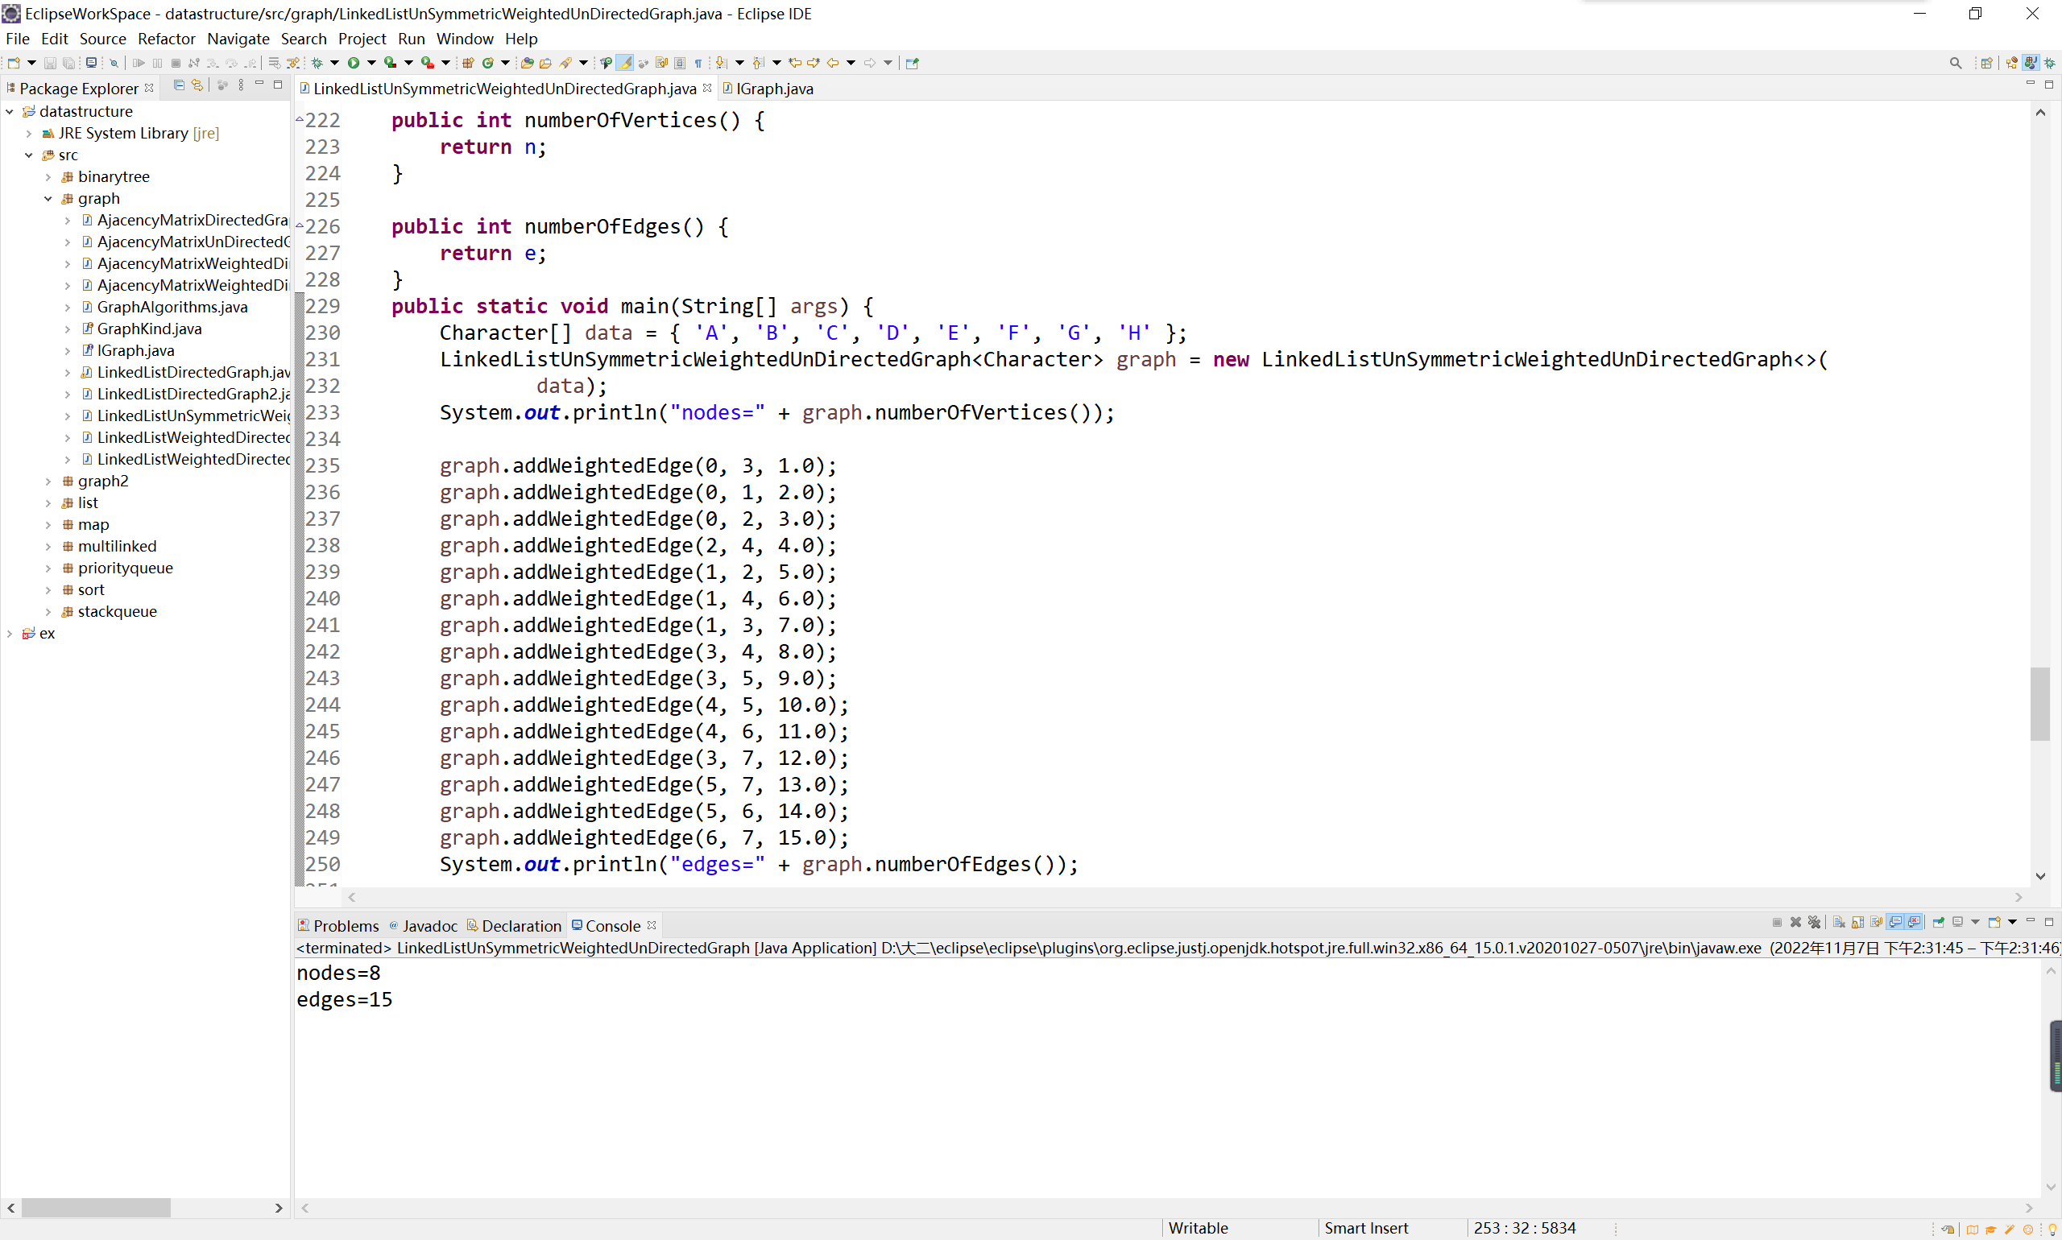
removeEdge()
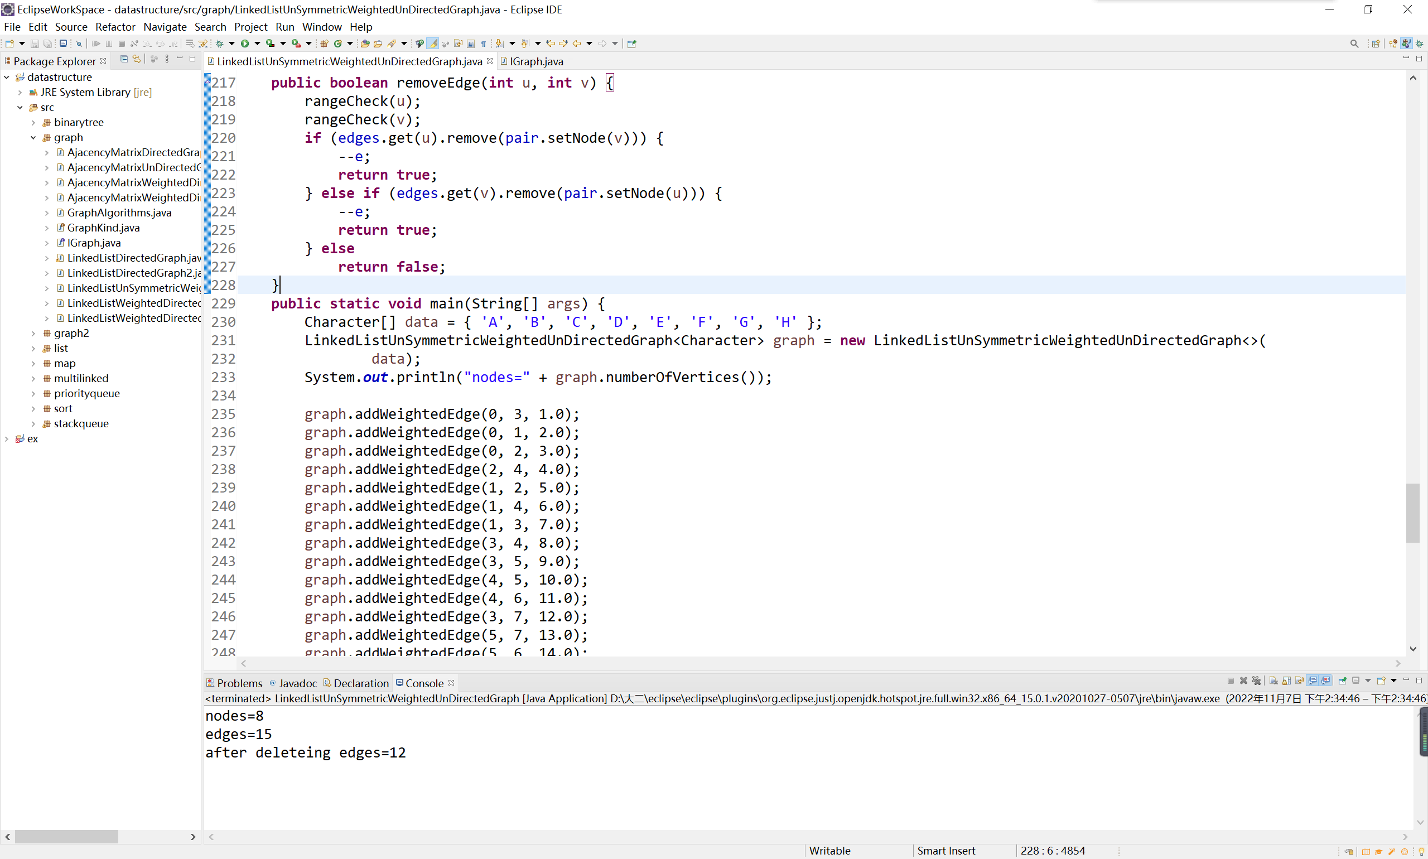
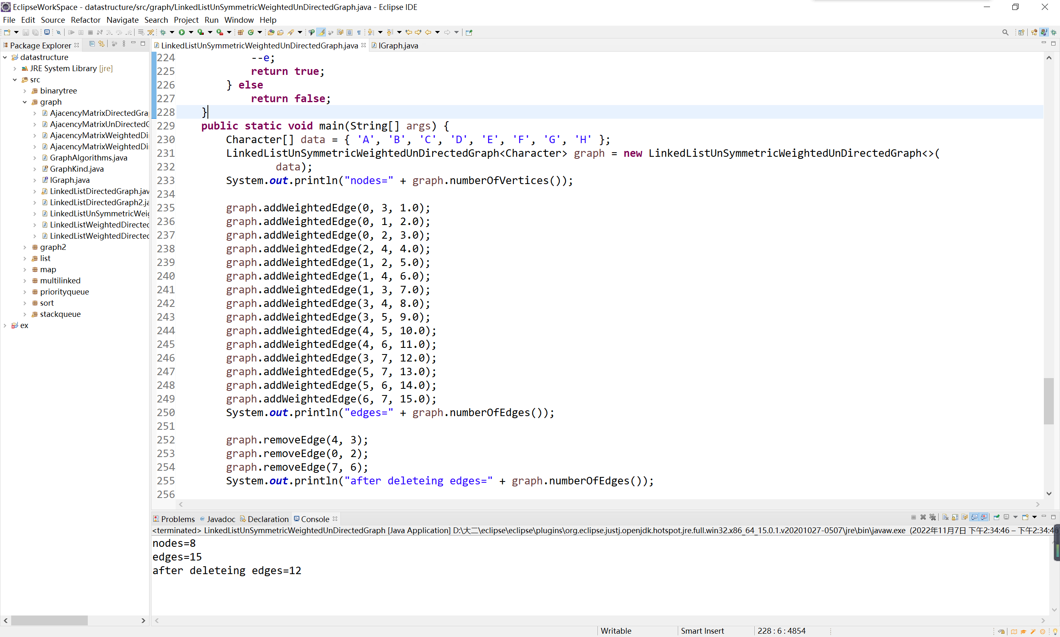

getWeight()
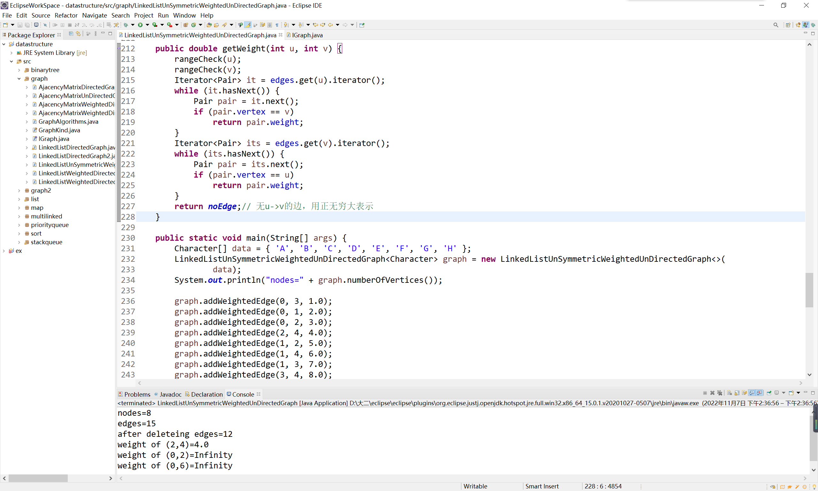
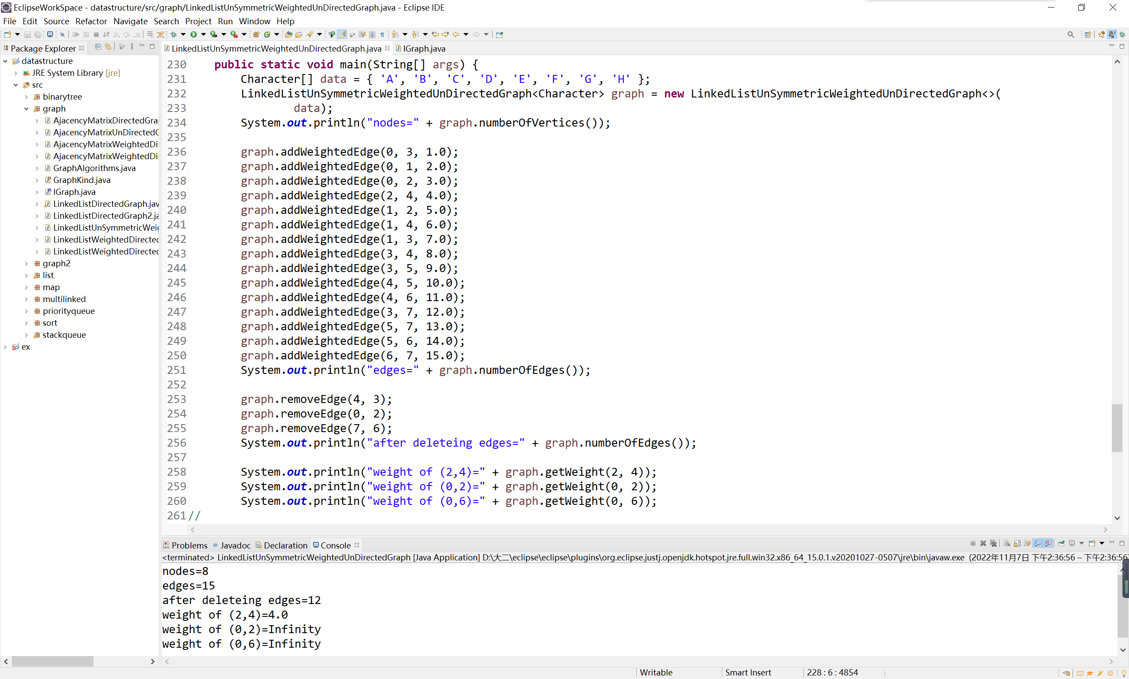

degree()
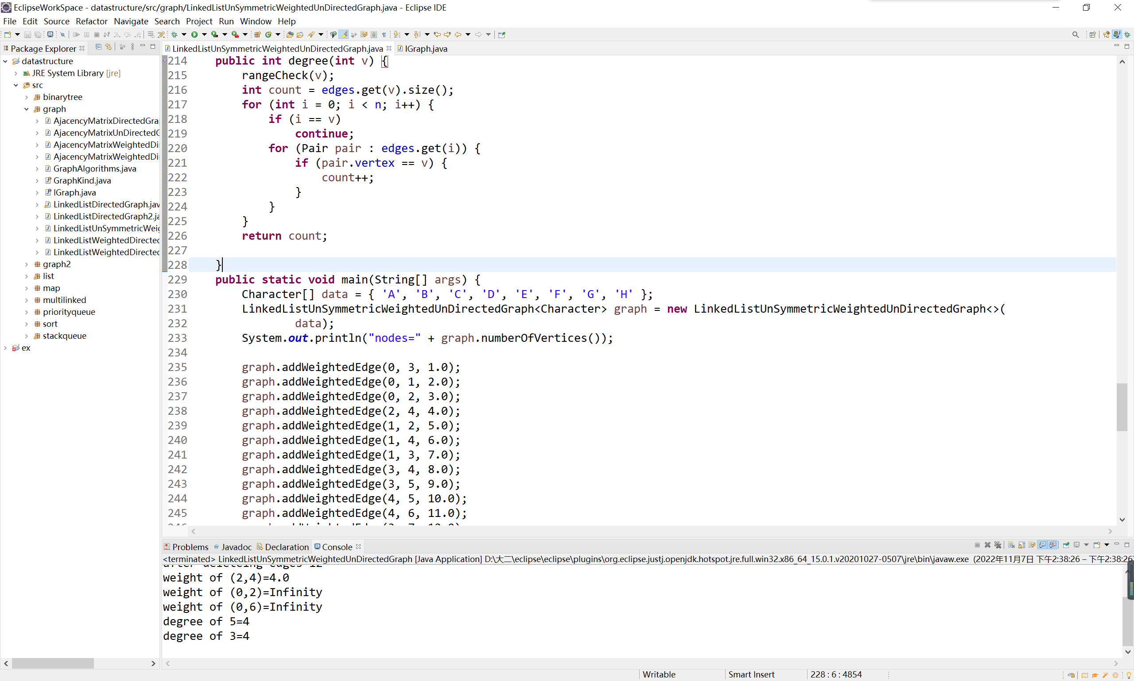
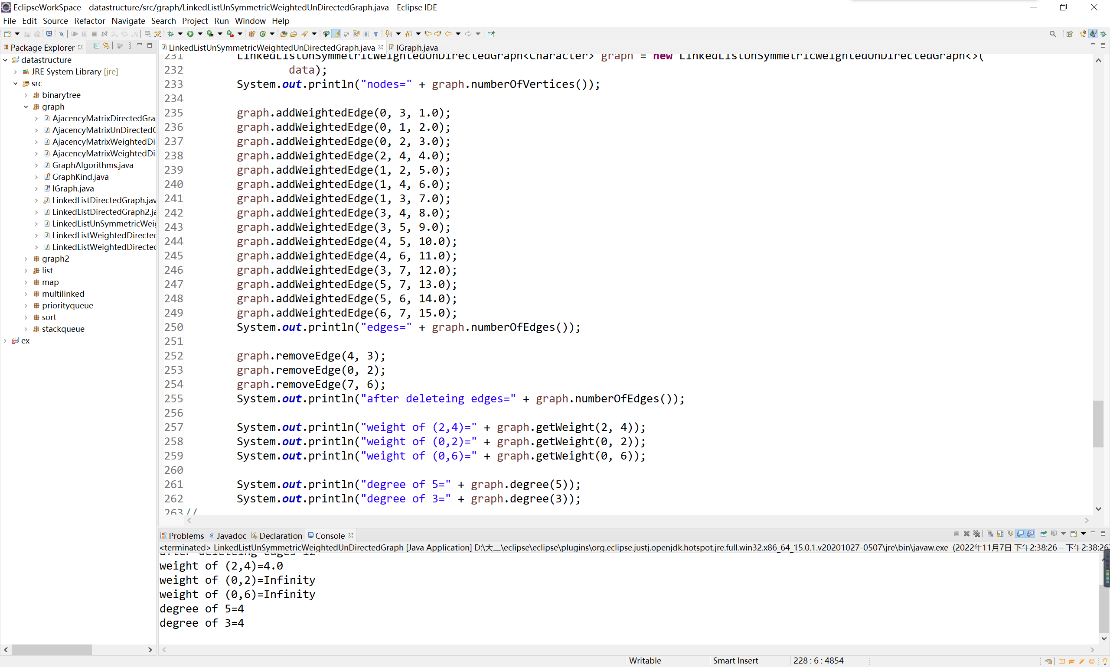

value()
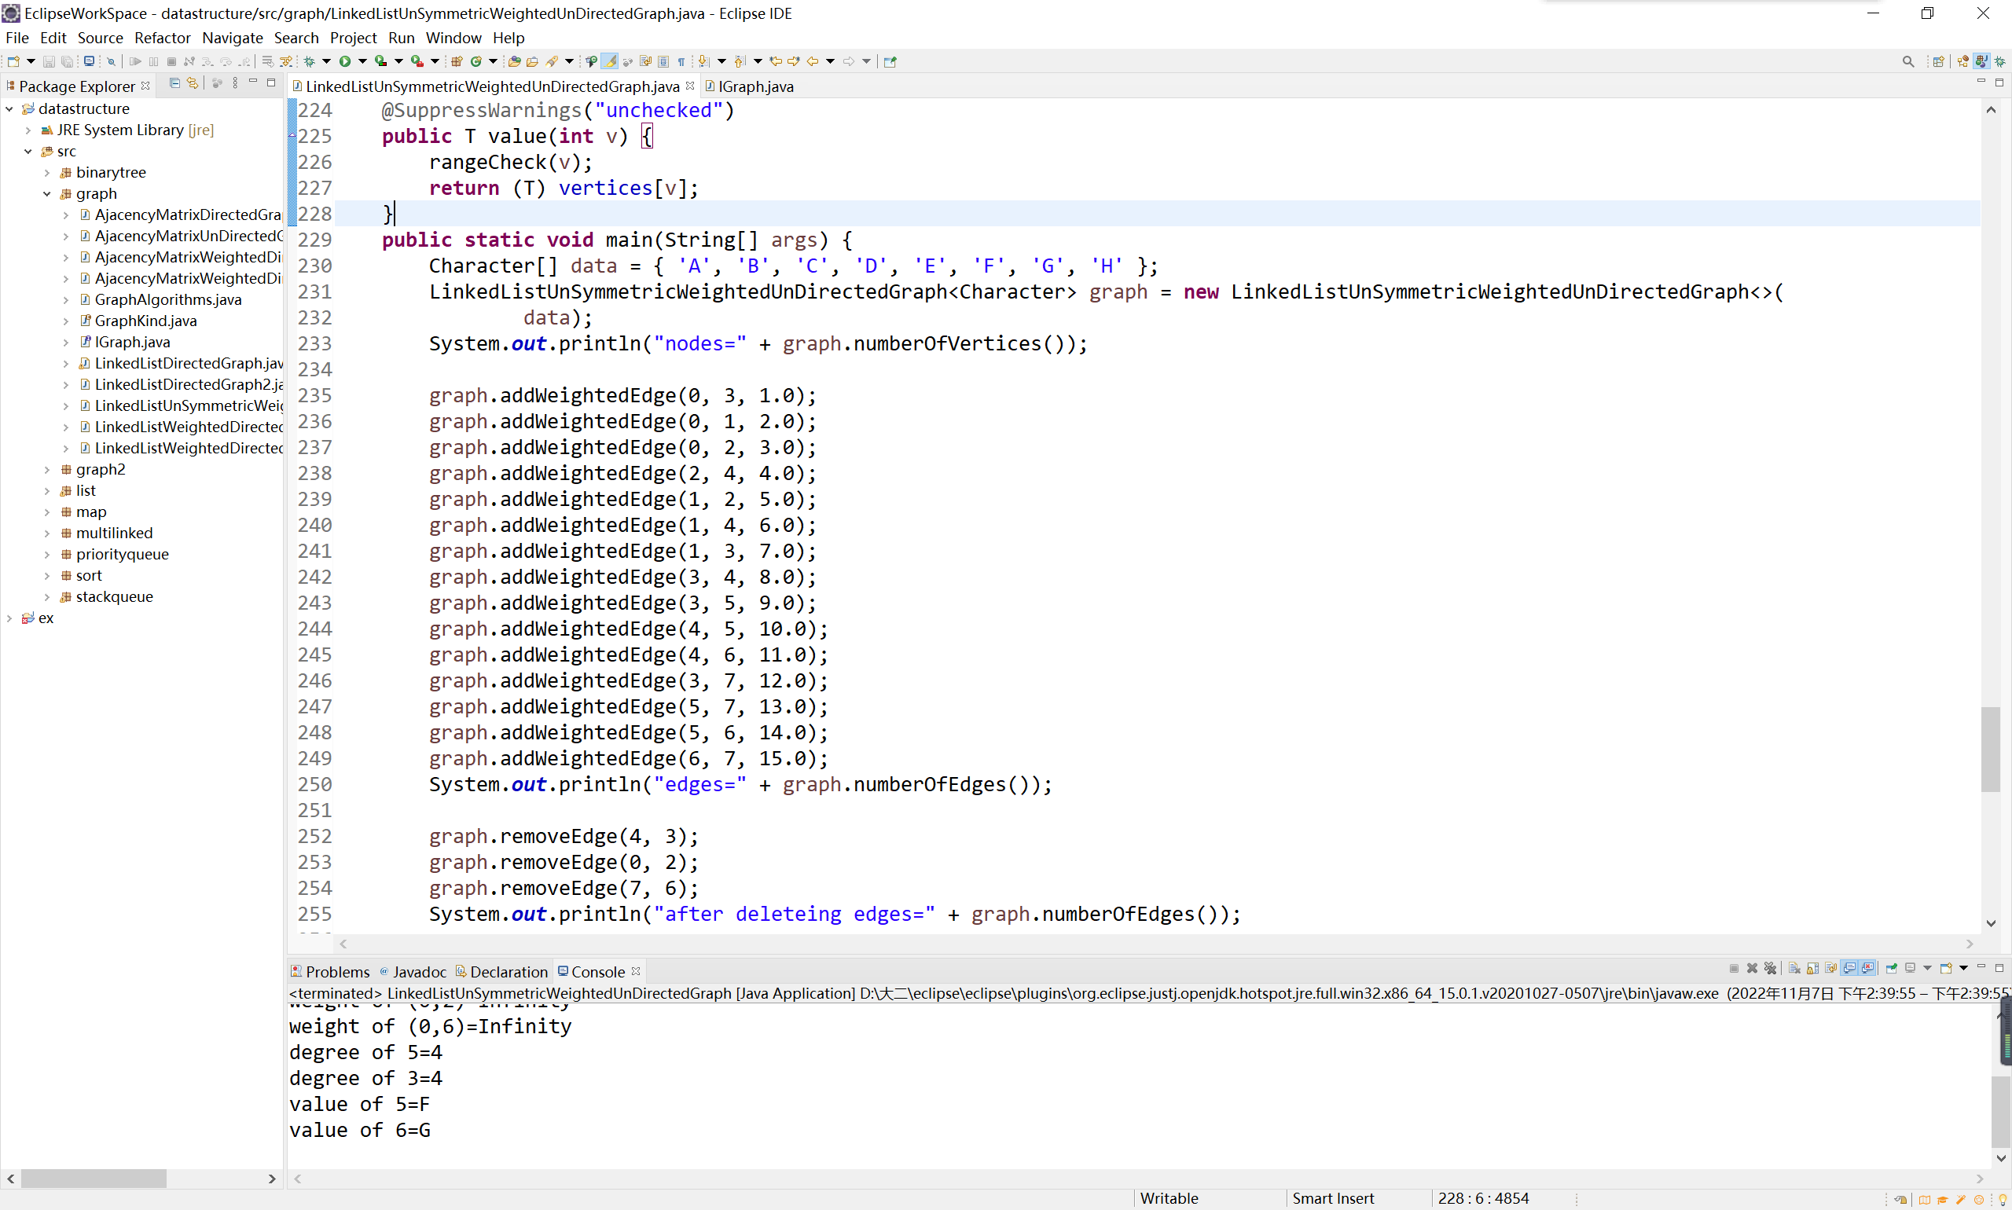
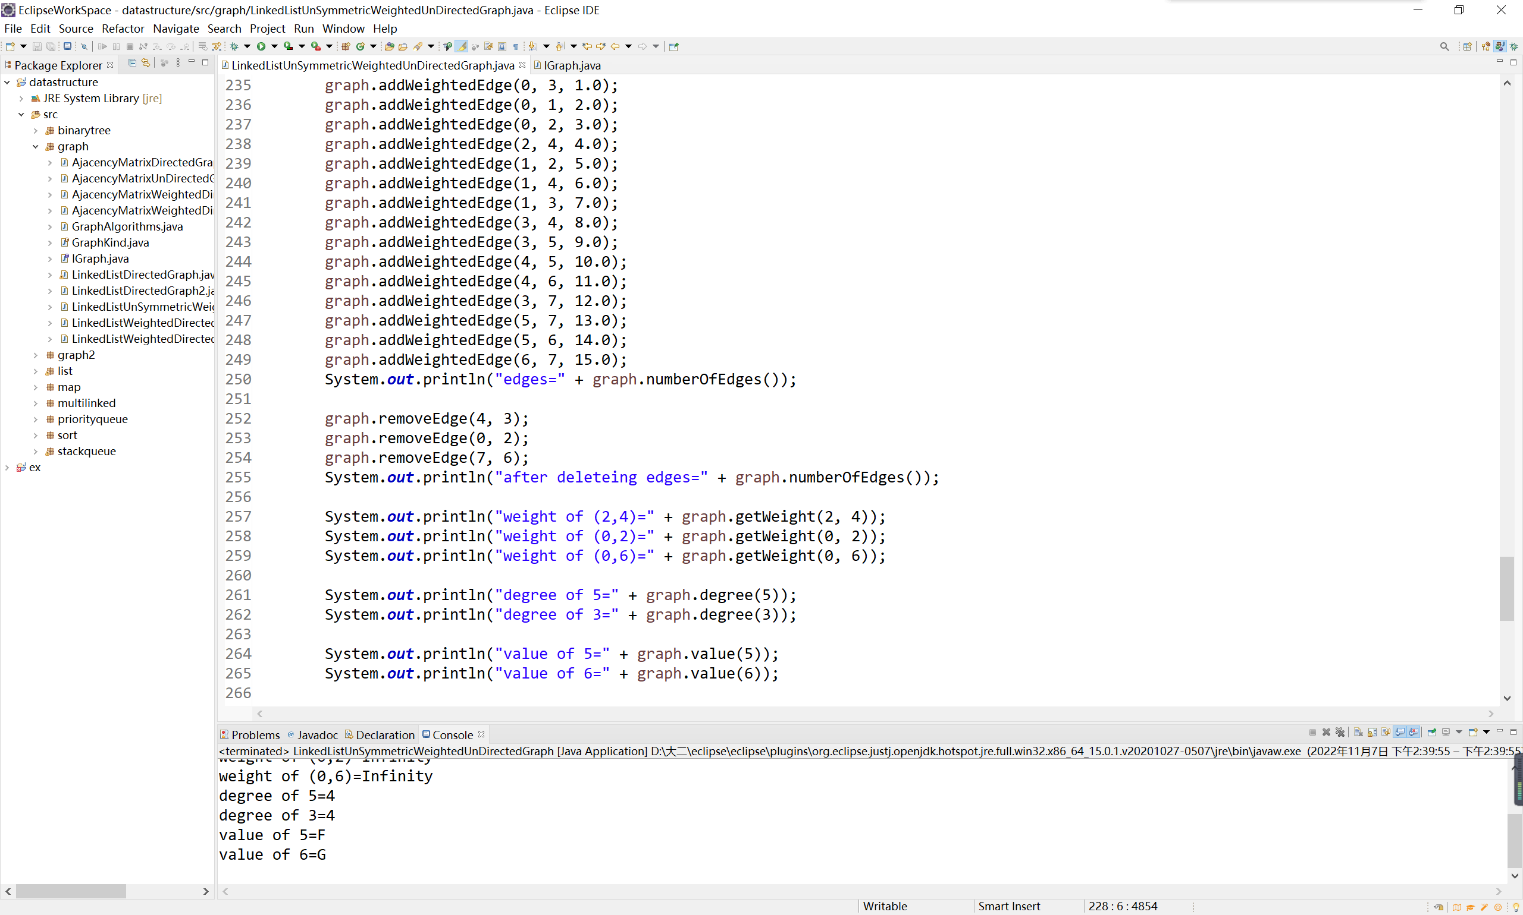

iterator()
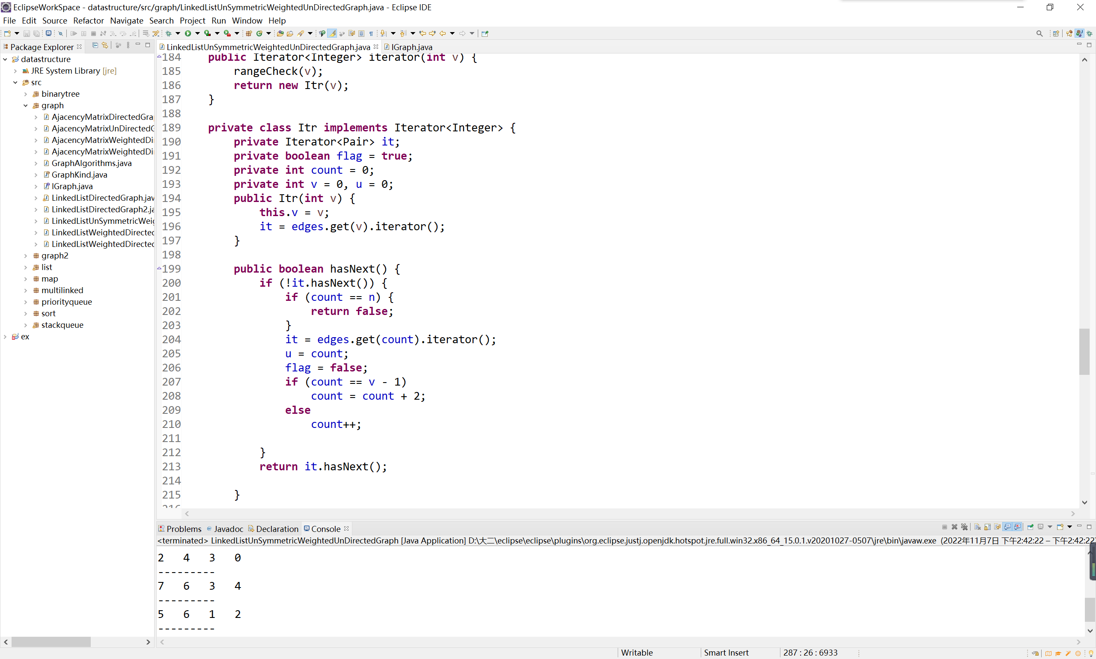
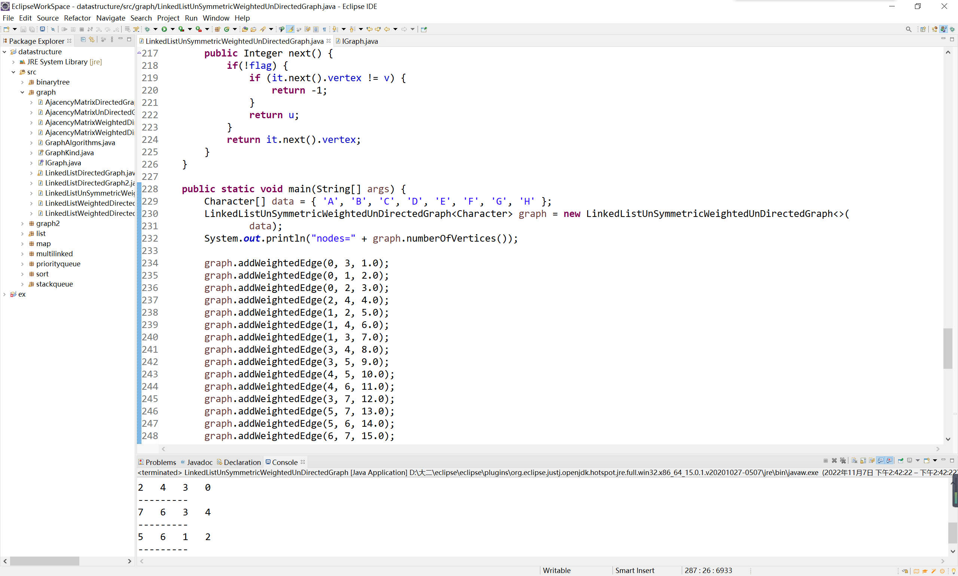
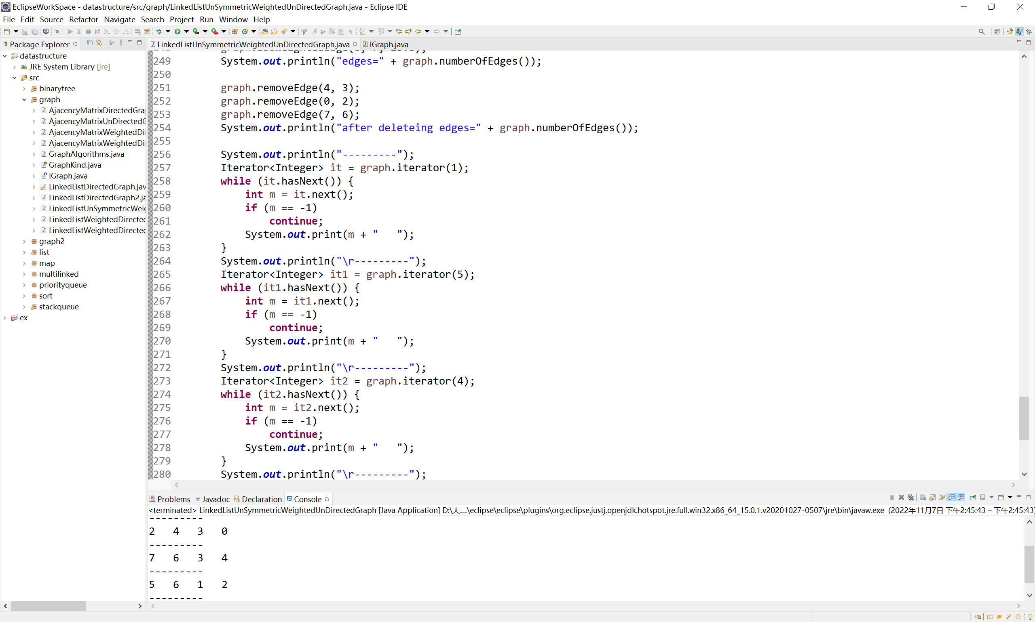
display()
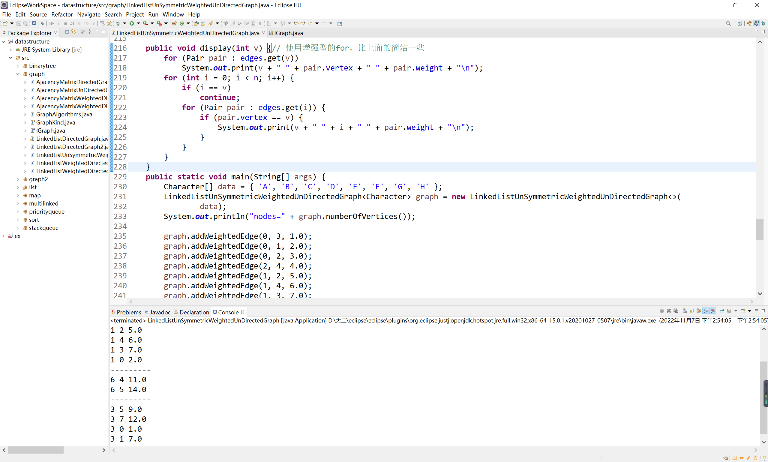
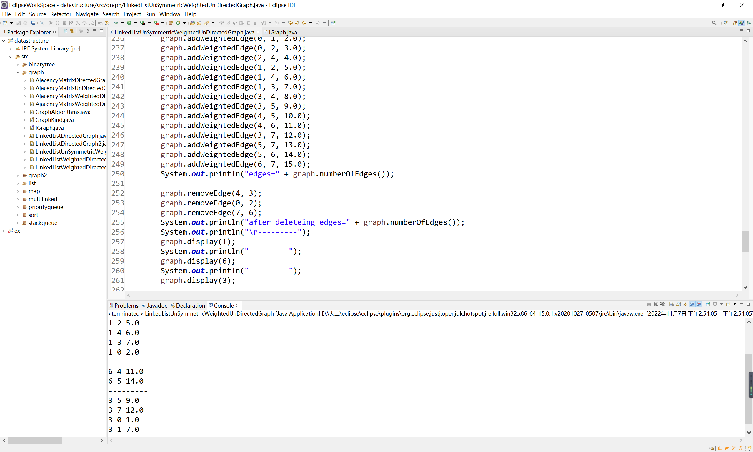

四、实验总结
“一条边只存储一次”这个问题一开始没有思路，后来用找比当前元素小的元素的方法，排除掉重复存储的边；明确了有向图和无向图在代码上的区别，比如无向图没有入度和出度；学会加、减带权重的边。

